DPV INTERNATIONAL
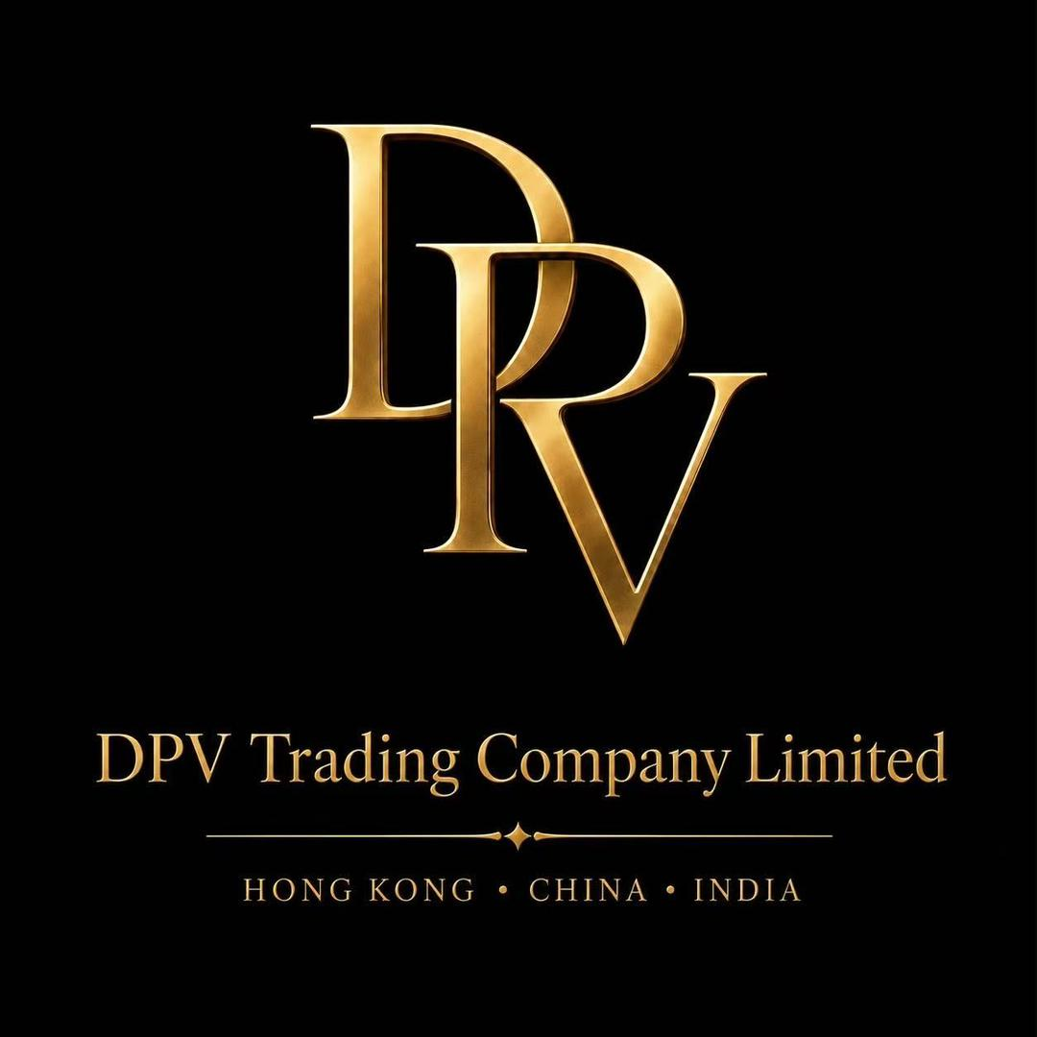
AI-Powered Overseas Lead Generation System
B2B Lead Discovery, Qualification and Conversion for Overseas Importer-Wholesalers
8 Weeks  Initial Delivery | Week 2  Prototype Demo | Week 5  Live Pilot | Week 8  Acceptance

Item | Details
Prepared for | DPV International Management and Business Teams
Version | V1.0
Date | August 2026
Classification | Internal Proposal

Contents
- 1. Executive Summary
- 2. Business Context and Overseas Target Buyers
- 3. Overseas Lead Source Strategy
- 4. Automated Lead Generation Workflow
- 5. System Architecture
- 6. Lead Scoring and Qualification Tiers
- 7. Company Data Requirements
- 8. Eight-Week Implementation Plan
- 9. Automation Roadmap
- 10. Acceptance Metrics and Risk Controls
- Appendices

1. Executive Summary
This proposal establishes an overseas B2B lead generation system for DPV International, combining multi-platform company discovery, data enrichment, lead scoring, product-to-buyer matching, multilingual outreach and conversion feedback. The sole priority segment in the current phase is overseas importers, wholesalers and distributors that import merchandise and supply local chain stores, regional retail networks and large retail accounts. B2C customer acquisition is outside the scope of this phase.
The initial delivery spans eight weeks. A demonstrable prototype will be available in Week 2, the multi-source lead database MVP will be completed in Week 4, live outreach will begin in Week 5 and acceptance will be completed in Week 8. Human approval remains mandatory during the initial phase, with controlled automation introduced only after data quality and operating performance are proven.
Primary outcome: a closed B2B operating loop for identifying, qualifying and converting overseas importer-wholesalers that supply chain-store and organized-retail channels.

2. Business Context and Overseas Target Buyers
DPV International is positioned as a bulk export supplier across women's, men's and children's apparel, bags, beauty products and household goods. Its operating footprint across Guangzhou, Hong Kong and India provides a foundation for sourcing and export coordination. The corporate website documents flexible MOQs, wholesale enquiries, FOB/CIF quotation practices and export-ready packing, and will serve as the system's company and product knowledge source.
Mexico will provide the baseline for proven importer-wholesaler profiles, product demand and outreach language. The United Arab Emirates will be the first new-market pilot, focusing on Dubai-based companies with verifiable importing capability, wholesale distribution coverage and supply relationships with chain stores or organized retail networks. Bangladesh will follow as the second expansion market using the same B2B qualification model.

2.1 Target Buyer Segments
- Companies legally engaged in importing, customs clearance and wholesale distribution in the target market
- Wholesalers and distributors that supply chain stores, regional retail networks, department-store groups or other large retail accounts
- Businesses with verifiable import records, warehousing or distribution coverage, stable purchasing capacity and recurring replenishment demand
- Verifiable purchasing directors, import managers, category managers, wholesale managers or company decision-makers

2.2 Qualification Boundaries
The current phase is limited to B2B companies that match the profile above. Individual consumers, consumer-retail acquisition, single-store or marketplace retailers without importer-wholesaler and chain-supply capability, private-label/OEM buyers, sourcing agencies and social accounts without a verifiable business entity are outside the active outreach pool. Duplicates, opted-out contacts and unverifiable contact records are also excluded.

3. Overseas Lead Source Strategy
Overseas platforms are combined across five roles: importer-wholesaler discovery, evidence of chain-store supply, buying signals, contact enrichment and B2B enquiry capture. Social and content platforms are used only for company discovery and B2B signal validation, not for consumer acquisition.
Source Type | Representative Channels | Primary Purpose | Initial Integration
Search & Maps | Google, Google Maps, Bing | Identify importer-wholesalers, warehouses and geographic coverage | Search/API and public-page parsing
Professional Networks | LinkedIn | Identify importers, wholesalers, distributors and purchasing decision-makers | Research tasks and human outreach
B2B Social Signals | Facebook, Instagram | Discover company pages, wholesale activity and chain-supply evidence | Public business signals and owned-account data
Industry Content Signals | TikTok, YouTube | Identify corporate brands, warehousing, distribution and industry activity | Official APIs and public metadata
B2B Marketplaces | Alibaba, Global Sources, TradeKey | Discover import buyers, wholesale enquiries and category demand | Platform-authorized export or API
Trade Data & Directories | ImportGenius, Panjiva, Kompass | Validate import activity, wholesale status, distribution coverage and capacity | Corporate accounts or public data
Events & Supplier Lists | Trade shows, trade associations, chain-supplier lists | Find exhibiting wholesalers, import distributors and chain-store suppliers | List parsing and entity matching

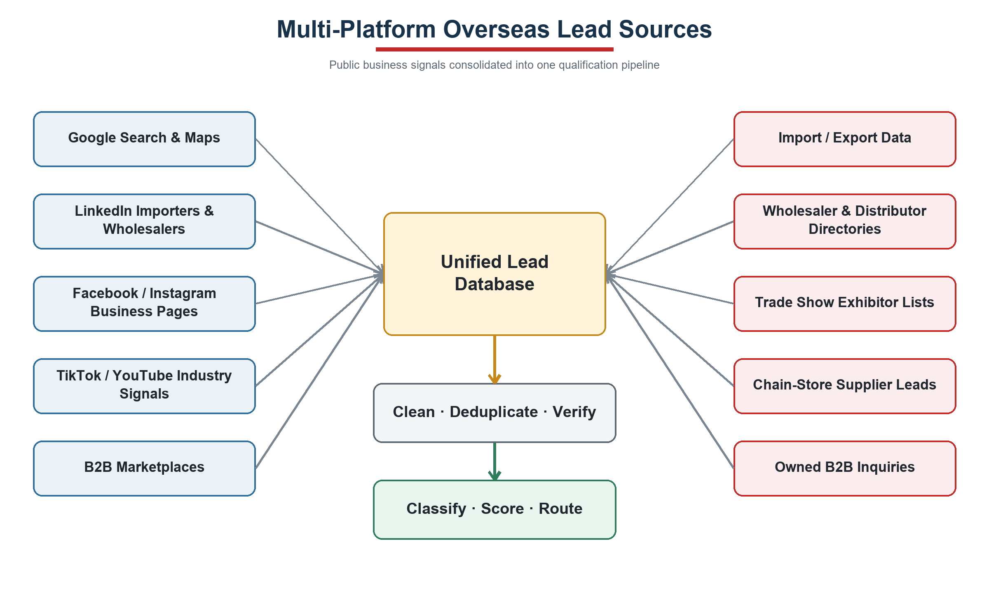
Figure 1. Multi-Platform Overseas Lead Sources
Platform signals are consolidated into unified company records before cleaning, deduplication, verification and qualification.

4. Automated Lead Generation Workflow
The system generates search strategies by market, city, product, importer-wholesaler profile and language, then acquires public business signals on a scheduled basis. Every candidate record retains its source URL, capture date and platform type before standardization, deduplication, contact verification, importer/wholesaler qualification, chain-supply evidence validation and product matching.
Tier A leads receive personalized email drafts, LinkedIn contact tasks and product recommendations. All outbound content requires sales approval during the initial phase. Follow-up stops immediately after a reply, opt-out, hard bounce or manual takeover. Replies are classified into quotation, catalogue, sample, defer, decline or irrelevant categories and routed to the appropriate sales action.
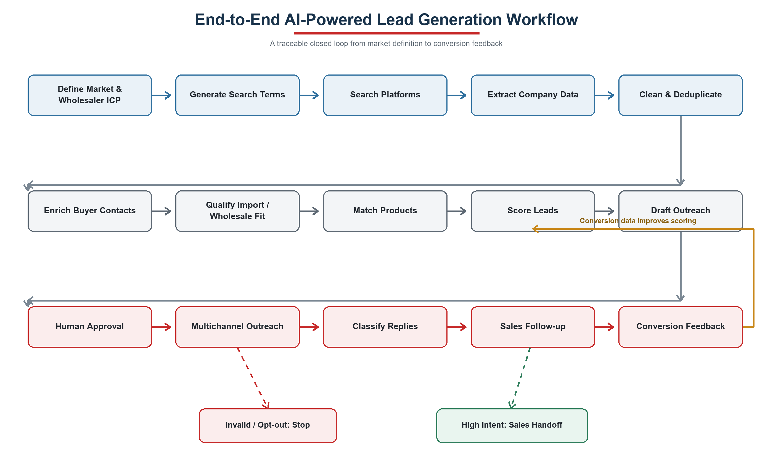
Figure 2. End-to-End AI-Powered Lead Generation Workflow
The workflow includes controls for invalid records, opt-outs, high-intent sales handoff and conversion feedback.

5. System Architecture
The solution uses a layered architecture built around n8n orchestration, a PostgreSQL data foundation, a CRM operating interface and large-language-model services. n8n manages scheduling, API integrations, approvals, alerts and write-back. PostgreSQL stores leads, products, campaigns, interactions, opt-outs and audit records. An existing CRM will be integrated where available; otherwise, NocoDB will provide the initial sales interface.
Language models support company classification, web-page summarization, product matching, multilingual copy and reply-intent detection. They do not independently determine prices, payment terms, contract terms or delivery commitments. Credentials are stored through controlled secrets management and all outbound actions are logged.

5.1 Layered Architecture
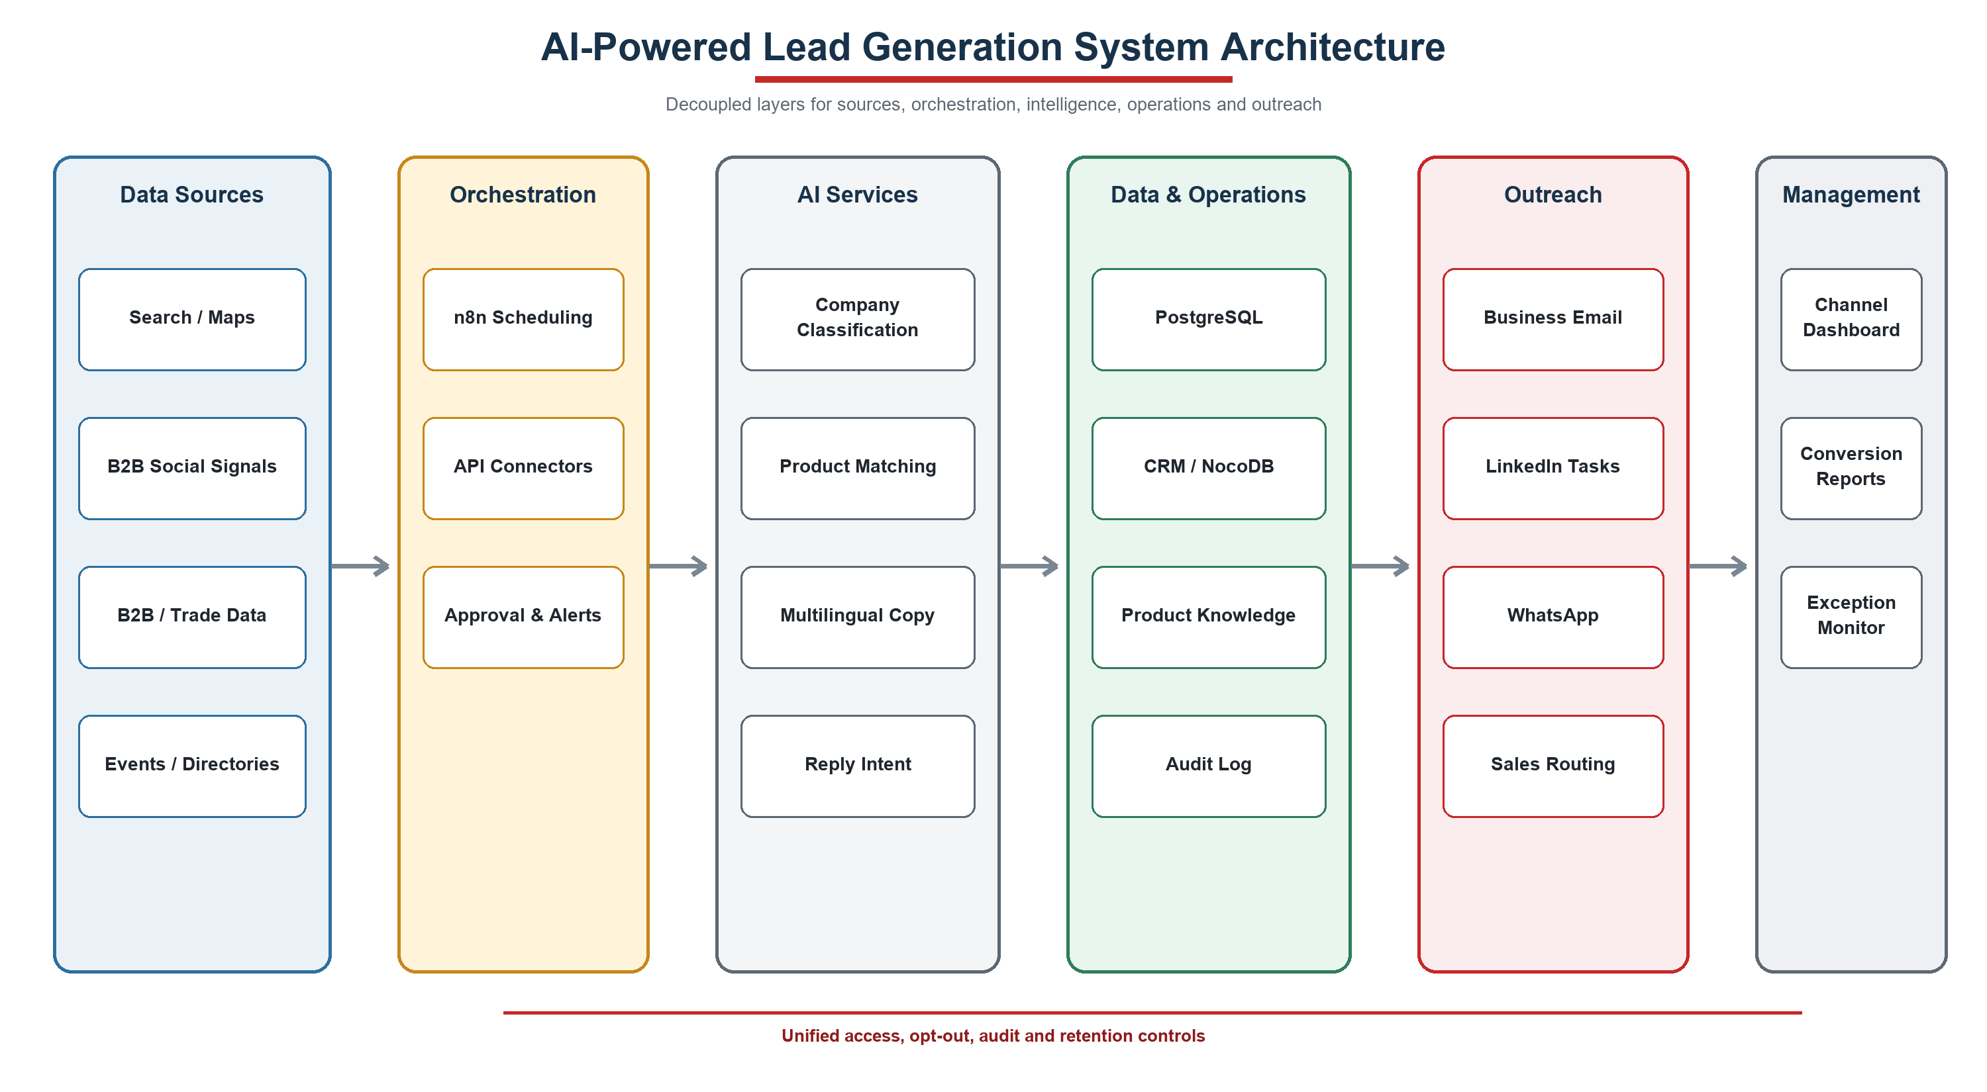
Figure 3. AI-Powered Lead Generation System Architecture
Standard interfaces allow individual platforms or model services to be replaced without changing the core data model.

6. Lead Scoring and Qualification Tiers
Scoring Dimension | Weight | Evidence
Product Fit | 20 | Category, price band, MOQ and wholesale buying use case
Market Fit | 15 | Country, city and chain-retail coverage area
Importer / Wholesaler Fit | 15 | Company has verifiable importing, wholesale or distribution functions
Import & Chain-Supply Evidence | 15 | Trade records, warehousing, wholesale positioning and chain-customer evidence
Distribution Scale | 10 | Warehouses, employees, territory, revenue or channel-network signals
Recent Buying Signal | 10 | New ranges, recruitment, events, content or import activity
Decision-Maker Quality | 10 | Role relevance and profile completeness
Contact Validity | 5 | Verified work email, business phone or approved channel

Tier A: 75–100; Tier B: 55–74; Tier C: below 55. Scores of 85 or above become eligible for automated first-touch only after the system is stable and send controls are satisfied.

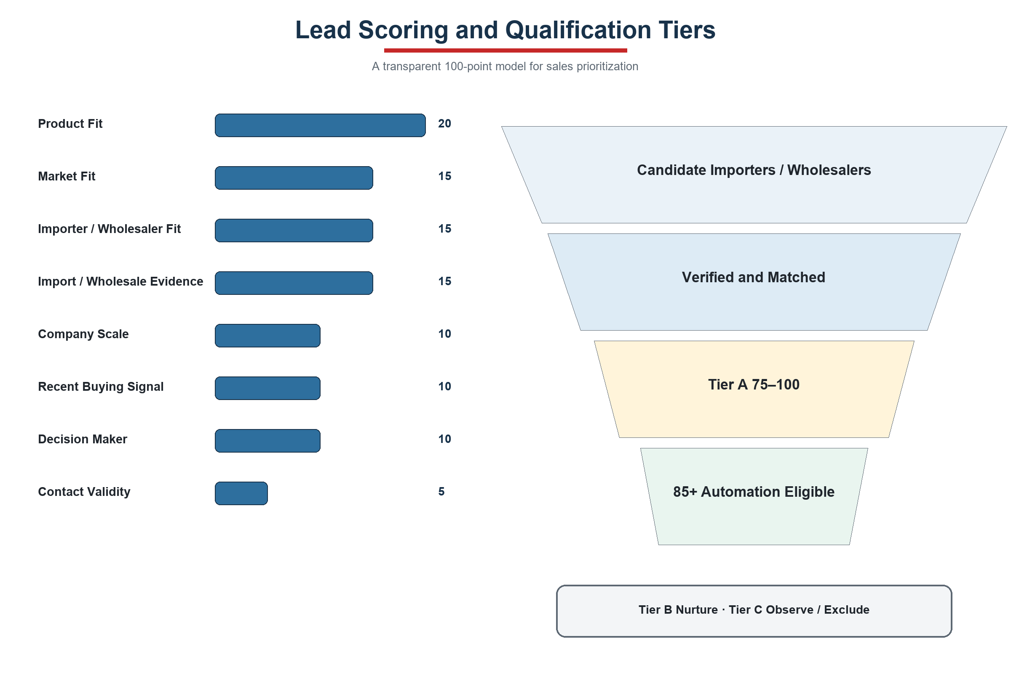
Figure 4. Lead Scoring and Qualification Tiers
Every score retains reason codes and source evidence so sales teams can review and explain the result.

7. Company Data Requirements
HR coordinates the request across management, sales, export operations, product, supply chain, finance and IT. The first submission consists of de-identified samples, field definitions and an account inventory; individual passwords are not transferred.
Priority | Data Package | Required Content | Coverage | Owner
P0 | Business Objectives | Target markets, importer-wholesaler ICP, chain-supply channels, priority categories, lead/conversion goals and exclusions | One-page management brief | Management
P0 | Historical Customers & Orders | Company, country, importer/wholesaler status, downstream chain channels, SKU, quantity, revenue, repeat orders and sales cycle | Past 12–24 months | Sales / Finance
P0 | Historical Lead Funnel | Source, importer-wholesaler qualification, chain-supply evidence, contact, outreach, reply, quotation, conversion and loss reason | 50 wins and 100+ losses/leads | Sales / Export
P0 | Product Master | SKU, material, size, MOQ, price tiers, FOB/CIF, samples, lead time, capacity, packing, certification and assets | 30–50 priority apparel SKUs | Product / Supply Chain
P0 | Sales Knowledge | Company profile, FAQs, quotation templates, successful copy, objections and prohibited claims | 20+ successful conversations | Sales / Management
P0 | Systems & Accounts | CRM, ERP, Excel, email, WhatsApp, social platforms, B2B platforms, APIs and owners | Complete inventory | IT / Administration
P1 | Channel Data | B2B website and WhatsApp enquiries, trade shows, trade directories, wholesale platforms and corporate social signals | Past 6–12 months | Marketing / Sales
P1 | Supply & Fulfilment | Categories, capacity, lead times, ports, certifications, complaints and restrictions by operating location | By entity and category | Supply Chain / Factories
P1 | Governance Rules | Approvers, lead assignment, suppression list, retention, send limits and exception handling | Current policies | Management / IT

7.1 Initial Sample Size
- At least 50 converted importers, wholesalers or distributors and 100 non-converted leads from the same segment.
- 30–50 priority SKUs and at least 20 successful B2B sales conversations.
- An initial pool of 200–500 candidate importer-wholesalers and approximately 100 live outreach records.

8. Eight-Week Implementation Plan
Phase | Timing | Primary Activities | Deliverables | Acceptance Gate
1 Requirements & Data | Week 1 | Interviews, data samples, product and market confirmation | Data register, ICP and system inventory | Scope and fields approved
2 Rapid Prototype | Week 2 | Database, n8n and first search workflow | 50 sample leads | Prototype demonstration
3 Multi-Source MVP | Weeks 3–4 | Acquisition, cleaning, deduplication and importer-wholesaler verification | Pool of 200–500 importer-wholesalers | MVP completed
4 Qualification & Matching | Weeks 4–5 | Chain-supply evidence, scoring, product matching and multilingual copy | A/B/C tiers and drafts | Accuracy sample passed
5 Approval & Live Outreach | Week 5 | Human approval, sending, reply monitoring and stop rules | Approximately 100 live contacts | Pilot launched
6 B2B Signals & Dashboard | Week 6 | Corporate social signals, B2B enquiry intake and channel reporting | Management dashboard and alerts | Full traceability
7 Optimize & Replicate | Week 7 | Optimize from pilot results and copy to second market | Bangladesh workflow | Rules reviewed
8 Acceptance & Handover | Week 8 | Testing, training, documentation and access review | System, guide and acceptance report | Initial acceptance

8.1 Project Roadmap
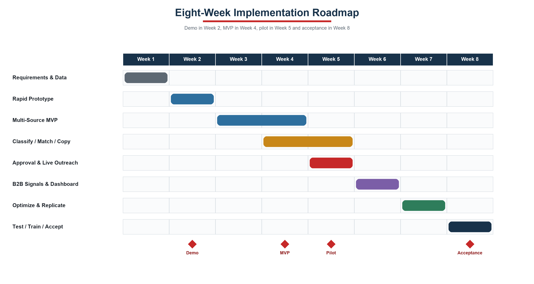
Figure 5. Eight-Week Implementation Roadmap
Milestones provide management with verifiable outcomes in Weeks 2, 4, 5 and 8 instead of deferring all value to project close.

9. Automation Roadmap
Stage | Timing | Automation Scope | Controls Retained
Initial B2B | Within 8 weeks | Importer-wholesaler search, qualification, scoring, matching and outreach drafting | Human approval for all sends; human confirmation for price, contract and delivery
Stage 2 B2B | 4–6 weeks after acceptance | Automated first-touch for 85+ importer-wholesalers, follow-up, catalogue delivery and reply routing | Daily caps, opt-out, bounce and exception stops
Stage 3 B2B | 6–8 weeks after stable operation | Additional markets, categories, B2B enquiries and scoring optimization | Approval remains for quotations, payment, contracts and material commitments
Future B2C | Separate project | Consumer acquisition, retail marketing and related channel automation | Outside the current scope; requires separate approval, data and implementation plan

10. Acceptance Metrics and Risk Controls
Metric | Target
Required-field completeness | ≥90%
Duplicate rate | <2%
Tier A importer-wholesaler precision | ≥80%
Hard-bounce rate | <5%
Source traceability | 100%
Initial-phase send approval | 100%
Manual research time reduction | ≥60%

10.1 关键风险控制
- Scope control: only companies matching the importer-wholesaler ICP with evidence of chain-store supply may enter outreach; consumers, ordinary retailers and other non-target B2B types are automatically excluded.
- Platform constraints: prioritize official APIs, authorized exports and public business data; create human sales tasks where automated messaging is unavailable.
- Data quality: retain source, capture time, verification status and score reasons; duplicates and stale records do not enter outreach.
- Content accuracy: outbound copy references only approved company knowledge and product master data; missing specifications are not invented.
- Send governance: enforce suppression lists, hard-bounce stops, daily caps, domain-reputation monitoring and manual takeover.
- Commercial commitments: quotations, payment, contracts, certifications and delivery commitments always require business confirmation.
- Access security: apply credential segregation, least privilege, activity logging and periodic retention review.

Appendix A: HR Data Coordination Checklist
- Nominate data owners across management, sales, export operations, product, supply chain, finance and IT
- Provide sample Customers_Orders, Leads_Funnel, Product_Master and Systems_Channels workbooks
- Provide Sales_Messages_FAQ documentation and product image/video folders
- Confirm field definitions, currencies, date formats, null-value meanings and update frequency
- Establish corporate account authorization without transferring personal passwords in spreadsheets
- Confirm owners for retention, opt-out, approval and lead assignment

Appendix B: Core Data Fields
Record | Core Fields
LeadRecord | Company, country, website, source, importer/wholesaler status, chain-supply evidence, distribution territory, purchasing contact, work email, language, score, stage, owner and opt-out
ProductRecord | SKU, category, material, size, MOQ, price tier, Incoterm, sample, lead time, capacity, packing, certification and assets
InteractionRecord | Lead ID, channel, time, direction, template, campaign, opens, clicks, replies, bounces, intent and disposition
CampaignRecord | Market, importer-wholesaler ICP, products, channel, keywords, copy version, send cap, leads, replies, quotations and conversions

Appendix C: References
- DPV International. Corporate website and product catalogue. https://dpvinternational.com/
- n8n Documentation. Workflow automation and AI integrations. https://docs.n8n.io/
- Google for Developers. YouTube Data API. https://developers.google.com/youtube/v3/docs
- LinkedIn Help. Accessing LinkedIn APIs. https://www.linkedin.com/help/linkedin/answer/a526048
- Meta. WhatsApp Cloud API documentation. https://www.postman.com/meta/whatsapp-business-platform/documentation/wlk6lh4/whatsapp-cloud-api

